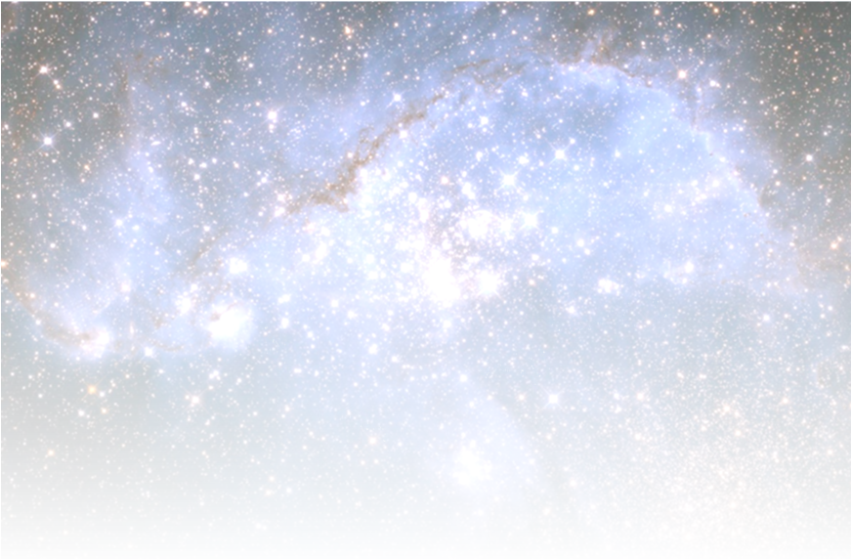**GOLDEN ARCH MONTESSORI SCHOOL**

**Is happy to host**

**Tare Zameen Par**

**Be immersed in a stunning 360 ̊ movie. Take a trip through the space, to the very edge of our Galaxy and then come back down to Earth to find out what’s in the sky tonight.**

**Duration of each show – Approx. 30 to 40 minutes**

**Sitting Capacity per show is 50**

|  |  |  |  |
| --- | --- | --- | --- |
| **Show timings** | **Shows** | **Grade** | **Ticket price** |
| **12 PM** | **Dinosaur Dusk** | **Kg to 2nd Grade** | **150/- per ticket** |
| **12:45 PM** | **Journey to the Centre of Universe** | **3rd to 5th Grade** | **150/- per ticket** |
| **2 PM** | **Edge of Darkness/ Microcosm** | **6th and 7th Grade** | **150/- per ticket** |
| **3 PM** | **Journey to the Centre of Universe** | **3rd to 5th Grade** | **150/- per ticket** |
| **4 PM** | **Dinosaur Dusk** | **Kg to 2nd Grade** | **150/- per ticket** |
| **5 PM** | **Dinosaur Dusk** | **Kg to 2nd Grade** | **150/- per ticket** |
| **6 PM** | **Dinosaur Dusk** | **Kg to 2nd Grade** | **150/- per ticket** |
| **7 PM** | **Cosmic Collision** | **3rd to 5th Grade** | **150/- per ticket** |

**Date – 11th January, 2020**

**Location - BBMP ground, Sector 2, HSR Layout**

**For tickets*, kindly contact 7022502244**

**Or mail your requirement to** [**goldenarch2004@gmail.com**](mailto:goldenarch2004@gmail.com)

**\*Kindly note, availability is on first come first basis. Tickets once sold cannot be refunded. Show can be viewed by both children and adult. It will be free for children under 3 years.**

**The Shows**

|  |  |  |
| --- | --- | --- |
| **No** | **Show** | **Description** |
| **1** | **Dinosaur Dusk** | **You'll travel back in time to meet the Pterosaurs and the ancestors of modern-day birds: the feathered dinosaurs. Lucy and her father navigate from continent to continent, looking for clues about the origins of flight.** |
| **2** | **Journey to the Centre of Universe** | **Takes to the journey to the heart of our galaxy, during seven minutes travel, faster than light from the driest place on earth, to the Atacama Desert in chili right to the centre of our own galaxy, where black hole is consuming anything that strays in the path** |
| **3** | **Edge of Darkness/ Microcosm** | **Edge of Darkness: The film features amazing scenes of places never before seen gathered by key space missions that culminated with ground breaking discoveries in 2015. It features a spectacular flight though the great cliffs on comet 67P, a close look at the fascinating bright "lights" on Ceres, and the first ever close ups of dwarf binary planet Pluto/Charon and its moons**  **Microcosm: Microcosm uses the latest discoveries of Nano scale science to create a voyage that is realistic and possible for inner space probes only a few nanometers wide. The experience is incredible, but so is the technology that has made imaging at this scale a reality.** |
| **4** | **Cosmic Collision** | **Explains journey, diving into the Milky Way Galaxy of several billion years ago. We approach a region in which stars are forming, where we encounter a protoplanetary disk surrounding our new-born Sun. We arrive at the young Earth, splashing down in deep water to visit a hydrothermal vent and to examine the formation of organic molecules** |